**Task 1:**

Write a Program in PHP that uses a multidimensional array to store and print information about individuals and their respective details. The array contains information in the format: [Name, Category, City].

# Array Definition:

* + $people is a multidimensional array where each sub-array contains details of a person: [Name, Category, City].

# Loop Through Array:

* + The foreach loop iterates through each sub-array ($person) in the $people

array.

# Print Details:

* + For each person, it extracts the name, category, and city, and then prints these details.

# Expected Output:

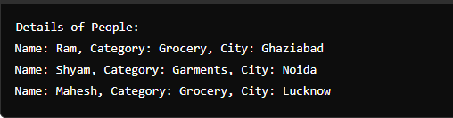

**Task 2:**

Write a PHP program that prints course names and their counts using an associative array.

# Array Definition:

* + The $courses associative array stores course names as keys and the number of students (or any count) as values.

# Loop Through Array:

* + The foreach loop iterates through each key-value pair in the $courses array.

# Print Course Details:

* + For each course, it prints the courseName and its count.

# Expected Output:

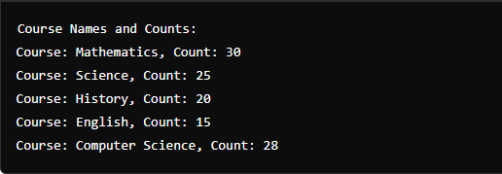

**Task 3:**

Write a program in PHP that prints employee names associated with their employee IDs using an associative array:

# Array Definition:

* + The $employees associative array stores employee IDs as keys and their names as values.

# Loop Through Array:

* + The foreach loop iterates through each key-value pair in the $employees

array.

# Print Employee Details:

* + For each employee ID, it prints the empId and the associated empName.

**Expected Output:**

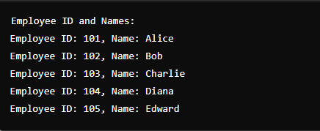

# Task 4:

Write a PHP program that prints a list of names and their ages using the provided associative array:

# Array Definition:

* The $people associative array contains names as keys and ages as values.

# HTML Structure:

* The echo statements are used to generate HTML content for better formatting.
* <h1> is used to display the main heading.
* <ul> and <li> elements are used to create an unordered list to display each person's name and age.

# Loop Through Array:

* The foreach loop iterates over the $people array.
* For each iteration, it extracts the name and age and displays them within a list item.

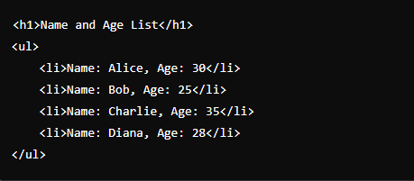

# Task 5:

PHP program that determines whether a given year is a leap year or not using if-else

statements.

# Function Definition:

* isLeapYear($year) function takes a year as input and determines if it is a leap year based on the leap year rules.

# Checking the Year:

* $year variable is set to the year you want to check. You can change this value to test different years.
* The if-else statement calls the isLeapYear function and prints whether the year is a leap year or not.

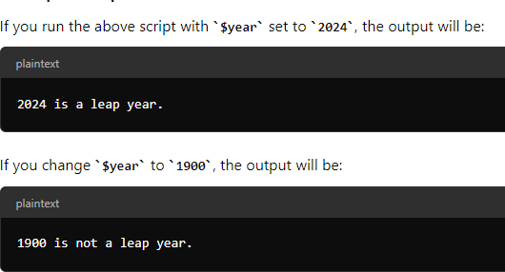

**Task 6:**

**Write a PHP program that uses a two-dimensional array to store data and then iterates through each element of the array to display it.**

**Row number 0**:

* Displays the first row’s data: "Manoj", 7.8, "pass".

# Row number 1:

* Displays the second row’s data: "Aditya", 8.5, "pass".

# Row number 2:

* Displays the third row’s data: "Anuj", 4.9, "fail".

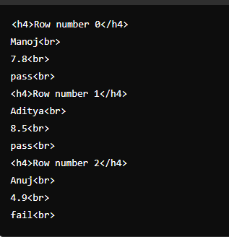

# Task 7:

Write a Program in PHP that displays information about a set of books using a nested

associative array. It iterates through the array, printing the book category (key) as a heading, followed by the details of each book (name and copies).

# Book Category:

* Each book category (e.g., "C++", "PHP", "Laravel") is printed as a heading (<h1>).

# Book Details:

* Under each heading, the details of the book (name and copies) are printed, with each key-value pair displayed on a new line.

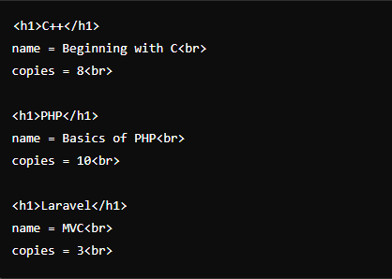

# Task 8:

Write a Program in PHP that uses the array_chunk function to split an array into smaller arrays of a specified size. Let's break down the code and its output.

# Array Definition:

* + $courses is an array containing a list of course names.

# array_chunk Function:

* + array_chunk($courses, 2) splits the $courses array into chunks, with each chunk containing up to 2 elements.

# print_r Function:

* + print_r is used to output the resulting array in a human-readable format.

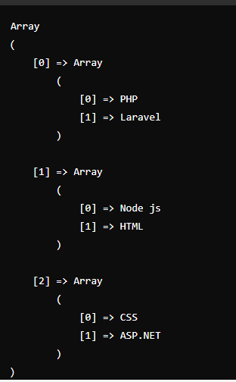

# Task 9:

Write a program in PHP that will produce the following output in the browser:

**Expected Output:**

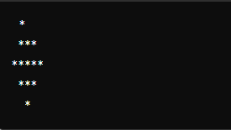

# Array Definition:

* $lines is an array where each element is a string representing a line of the pattern.
* Iterates over each element in the $lines array.
* Each line of the pattern is printed followed by an HTML line break (<br>).

# Task 10:

Write a program in PHP to print employee names and their associated company names using an associative array in PHP, you can follow these steps:

1. **Define an associative array** where each key represents an employee's name and the value is the company they work for.
2. **Iterate over the array** and print out each employee's name and company.

# Array Definition:

* + $employees is an associative array where:
    - Keys represent employee names.
    - Values represent the company names where the employees work.

# foreach Loop:

* + The foreach loop iterates over each key-value pair in the $employees array.
  + echo statements print the employee's name and company, with <br> tags to ensure each piece of information appears on a new line.

**Expected Output:**

